Information Retrieval Final Project Report

IR Final Project (2025–2026)
Students Information
Roi Bublil 322352659, roibub@post.bgu.ac.il
Hadar Shir 314624842, hadaraf@post.bgu.ac.il
Github repo link
https://github.com/ROIBUB/ir-final-project-2026.git
link to the Google Storage Bucket
https://storage.googleapis.com/roi-ir-bucket-1919
List of all index files
Have been saved and attach to the project on git in directory files and the file name index_files.txt
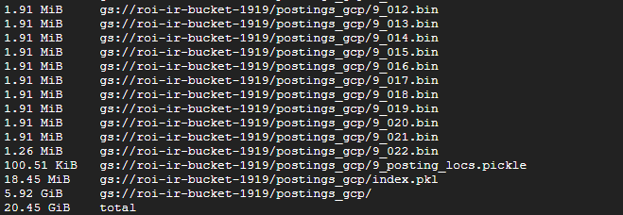

Experiments
We implemented and evaluated a retrieval system based on multiple scoring components applied to the document body.
The core retrieval signal is TF-IDF with cosine similarity, computed using an inverted index built over the corpus.
In addition, a BM25 score is computed for each query–document pair in order to account for term frequency saturation and document length normalization.
The final document ranking is obtained by combining the TF-IDF and BM25 scores using a fixed linear combination.
To further incorporate global document importance, PageRank values are integrated into the scoring function as a multiplicative boost.
This boost is applied with logarithmic scaling and a small weight, ensuring that PageRank acts only as a secondary signal and does not override textual relevance.
All components are applied consistently across all queries, resulting in a single fixed retrieval configuration that is evaluated end-to-end.

Evaluation Methodology
Evaluation was performed using metrics and evaluation functions based on the code provided by the course staff in their Colab notebook. The provided query set (queries_train.json) was randomly shuffled using a fixed random seed and split into training (70%) and validation (30%) subsets.
For each query, the search engine returns up to 100 ranked documents.
Performance is measured using the following metrics, exactly as defined in the course materials:
- Precision@5, measuring the relevance of the top-ranked results
- F1@30, capturing a balance between precision and recall at a deeper cutoff
- results_quality, defined as the harmonic mean of Precision@5 and F1@30
In addition to aggregate scores, per-query diagnostic output was examined, including overlap between predicted and relevant documents within the top 40 results.

Key Findings and Observations
Across the full evaluation, the system achieved an average results_quality score of 0.418 on the training set and 0.407 on the validation set.
The relatively small difference between training and validation performance indicates stable behavior and no significant degradation when evaluated on unseen queries.
Analysis at the query level shows substantial variability in performance.
Highly focused and specific queries (e.g., well-defined historical topics) often achieve high Precision@5 values, in some cases reaching perfect precision in the top results.
In contrast, broader or more ambiguous queries tend to yield lower precision and recall, reflecting the increased difficulty of ranking relevant documents for such information needs.
Overall, the evaluation demonstrates that the implemented retrieval pipeline produces consistent results across query subsets, while highlighting natural performance differences between focused and broad queries.

